Forces and Motion Quiz

1. What is the net force acting on the box?

20 N

5 N

10 N

1. If the box has a mass of 5 kg, what is the acceleration of the box?
2. On Earth, a person has a mass of 30 kg. What is his weight?
3. If the person moved to another planet where gravity was less than on earth, his mass would __________
   1. Stays the same as on earth
   2. Increase
   3. Decrease
4. A ball is dropped off a cliff. It takes the ball 3 seconds to hit the ground.
   1. What is the ball’s instantaneous velocity when it hits the ground?
   2. What is the average speed of the ball?
   3. What is the total distance traveled by the ball
5. Newton’s 1st Law, an object at rest stays at rest and an object in motion stays in motion with the same speed and direction is similar to what concept? ______________
   1. Weight
   2. Inertia
   3. Acceleration
   4. Electricity
6. A car’s velocity decreases from 30 m/s to 15 m/s in 5 seconds.
   1. Is the acceleration going to be positive or negative? Why?
   2. What is the car’s acceleration?
7. Mr. Marchant walks 5 meters to the left and then 3 meters to the right.
   1. Draw Mr. Marchant’s path
   2. What is Mr. Marchant’s total distance traveled?
   3. What is Mr. Marchant’s displacement?
8. On a position versus time graph, a person’s slope is 2. What is the velocity of that person?
9. A man is standing on a swing held up by 2 cables. The man has a mass of 50 Kg.



* 1. What is the man’s weight?
  2. If one cable has a tension force of 400 N. What is the tension force in the other cable?

A

The picture below shows a “top-down” view of the path of a toy airplane attached to a string being spun in a circular path above someone’s head.

1. The force that bends the object in a circular path is called? ____________________
2. If the string breaks while the plane is at the top of the circle, which direction will the plane fly in?______________
3. Why does the plane move in that direction if the string breaks?
   1. Kinetic energy
   2. Inertia
   3. Impulse

B

C

D

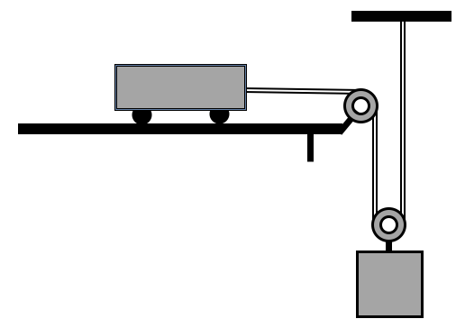

Force on string = 9N

M=1 kg

Friction = 4 N

* 1. What is the net force on the cart?
  2. What is the cart’s acceleration?
  3. If the cart has an initial velocity of 0 m/s, what will the cart’s velocity be after 4 seconds?

1. A ball is kicked into the air with an initial velocity of 25 m/s. What is the ball’s total time in the air?

Vi=25 m/s

Vf=-25 m/s

1. A sky diver has a mass of 50 kg.

Fair= 600 N

1. What is the skydiver’s net force (Make sure to include the direction)?
2. Is this force slowing him down or speeding him up?
3. What is the skydiver’s acceleration (Make sure to include if it is positive or negative)?
4. If the skydiver has an initial velocity of 20 m/s what is his velocity after falling for 4 seconds?

C:\Users\Ms. Banchik\AppData\Local\Microsoft\Windows\Temporary Internet Files\Content.IE5\Z6Z90JHB\MC900365896[1].wmf

Fg=500 N

1. Two planets are initially 1 meter apart. One planet is moved and now the two planets are 4 meters apart.

Before (1 Meter) After(4 Meters)

The gravitational force between the two planets after they are moved will be ______________

1. 4 times stronger
2. 4 times weaker
3. 16 times stronger
4. 16 times weaker
5. Remains the same
6. Two blocks sit on a seesaw. The block on the left has a weight of 100 N and sits 2 meters from the fulcrum. The block on the right sits 4 meters away from the fulcrum. What is the weight of the box on the right?

1. What is the weight of the box on the right?
2. What is the mass of the box on the right?