Name_____________________
Period____________________

Phase Changes
Use full and complete sentences

- Open up the Microsoft Excel App on your computer.
- Go to “file” on the top of your screen and select “new workbook”
- Using the “A” column, fill in your data from the lab. In box 1, fill in your data for minute 1, etc. Fill in all 25 minutes.
- Select “insert” on the toolbar of Excel. When you do this, you will see some different chart types. Click on “line” and then click on “line” for the type of line chart.
- This will produce a visual graph of the data you collected. Copy this graph and paste it to this document after the diagram below.
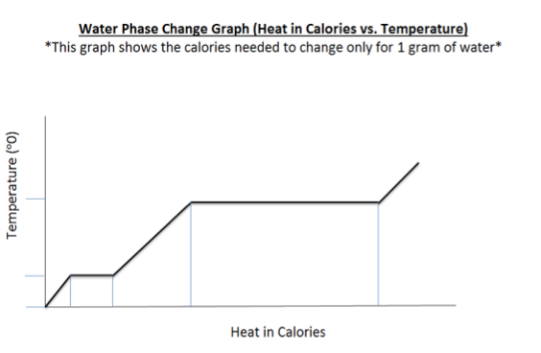
*Paste your excel graph here:

- Phase changes typically involve large amounts of energy compared to specific heat .
  - The phase change from ice to water takes 80 calories/gram
  - The phase change from water to steam takes 540 calories/gram
Fill in these numbers on your graph using the display on the overhead. Do this both on your personal graph and the graph provided.

- According to your data table and or graph:
  - At what temperature does your water start to boil?

  - At what temperature does your ice begin to melt?

  - When ice melts to water it’s experiencing a phase change from a solid to a liquid. What do you observe happening to the temperature of the ice water mixture as the phase change takes place?

  - When does the temperature begin to start changing again?

  - When liquid water boils it’s experiencing a phase change from a liquid to a gas. What do you observe happening to the temperature of the boiling water as the phase change takes place?

- As you continued to add constant heat (energy) into the flask with water, what happened to the temperature as the water started to boil? Why do you think there was a lack of temperature change during the phase change?

- At what temperature does water begin to boil at on the Celsius scale?

- At what temperature does water freeze on the Celsius scale?

- What are some reasons why your water may have had a different boiling or freezing point during your lab?

- What is the difference between heat and temperature?

- How many calories of heat are needed to change 1 gram of 0˚C ice to water at 0˚C?

- How many calories of heat are needed to change 5 grams of ice to water at 0˚C?

- How many calories of heat are needed to change the temperature of 1 gram of water by 1˚C?

- How many calories does it take to change 1 gram of 100˚C boiling water to steam at 100˚C?

- How many calories of heat are needed to change the temperature of 1 gram of water from 10˚C to 60˚C?

