Name_____________________
Period____________________

Bell Work
Show all work. Use the equations d=½a$t^{2}$ and v=at

Time  sec. | Velocity  v=at | Distance  d=½a$t^{2}$
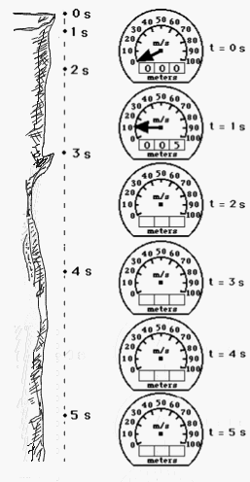
- A rock is dropped from a rest position at the top of a cliff and free falls to the valley below. Use the kinematic equation shown above to determine the distance fallen and the instantaneous speeds after each second. Indicate these values on the odometer (distance fallen) and the speedometer views shown to the right of the cliff. Round all odometer readings to the nearest whole number.
- At which of the listed times is the acceleration the greatest? Explain your answer.
- At which of the listed times is the speed the greatest? Explain your answer.
- If the falling time of a free-falling object is doubled, the distance fallen increases by a factor of _________. Identify two times and use the distance fallen values to support your answer.
- What would the speed and distance fallen be at 6 seconds? At 15 seconds?

Use the table below to calculate your velocity and distance

